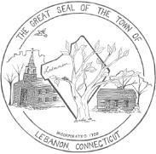
Town of Lebanon
CEMETERY COMMISSION
Regular Meeting Agenda
Tuesday, March 19, 2024 @6:00pm
Lebanon Town Hall 579 Exeter Road, Lebanon, CT 06249

- Call to order and roll call
- Public Comments
- First Selectman’s Address
- Sexton’s Report
- Correspondence
- Budget and Finance Report
- Old Business
  - North Lebanon Cemetery
    - Equipment screening area
    - Stone wall construction
    - New road
    - Scatter Area
  - National Historic Registry recognition for Trumbull Cemetery
  - Green burials – sub-committee report
  - Mowing Contract
  - Sexton and backup salaries
- New Business
  - Historical Society Newsletter
  - May Special Meeting, location to be announced
  - Switch meeting dates to second Tuesday
  - Plaque for Mary Trumbull Williams
  - Cemetery Work Day (Goshen)
- Other business proper to be brought before the Commission.
- Approval of minutes of previous meetings
- Adjourn

