WALK-IN COVID VACCINE & BOOSTER CLINIC

Where: Lebanon Senior Center
37R West Town St

When: November 8, 2021

Time: 3:00 PM – 6:00 PM

Vaccine Offered: Janssen (J&J), Moderna, Pfizer
1st,2nd, third, and booster doses available-please bring your vaccine card

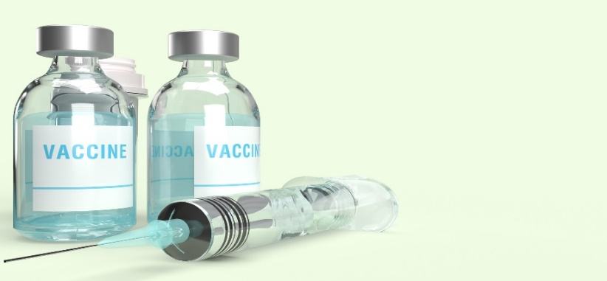
No Insurance Required
No ID Required

Appointments
also available in the
Uncas Health District office
every Wednesday from 10 AM – 12 PM
Please call for an appointment (860) 823-1189 x 109

401 West Thames Street, Suite 106, Norwich, Connecticut 06360
(860) 823-1189 www.uncashd.org Fax (860) 887-7898

